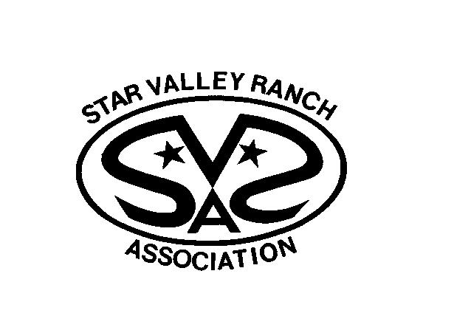
OPERATING POLICY
POLICY TITLE: Member Information Privacy Policy
SECTION | Member Services | NUMBER | 10.3 | DATE | 3/17/2022
REPLACES POLICY NUMBER: | TITLE:
DATE ADOPTED:
DATE REVISED:
CROSS REFERENCES:
APPROVED: |  |  | 3/17/2022
GENERAL MANAGER |  |  | DATE
 |  |  | 3/17/2022
SVRA CHAIRPERSON |  |  | DATE

It is the policy of the Star Valley Ranch Association to protect the privacy of its members. Member ownership and mailing addresses are public information and will be provided upon request. Email(s) or phone number(s) are provided to the Association for Association business and shall not be provided upon request.

SVRA will provide email or phone numbers upon request to Star Valley Ranch Association Board members and government employees, including but not limited to the Town of Star Valley Ranch, Lincoln County Sheriff, Wyoming Highway Patrol, United States Postal Service.

