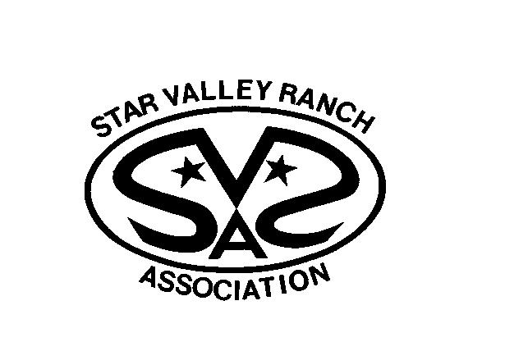
+The vision of the SVRA is to provide and promote well-maintained facilities and promote affordable recreational and social opportunities for its community under the provisions of the DCC&Rs.

CORPORATE SECRETARY’S GREETING

Dear SVRA Members,

The SVRA Board of Directors has voted to proceed with a vote of the membership to amend the By-Laws of Star Valley Ranch Association. The information provided in this mailing is to notify the SVRA members of the upcoming By-Law Amendment Meeting and vote.

Included in this mailing is a copy of the By-laws with the desired changes. Deletions are in yellow and additions are in green. These changes include removing the reference of Leisure Valley Incorporated throughout, updating Article XI Section 4 to include the proposed changes, and the necessary quorum for the Annual Meeting. The past several elections have proved difficult to achieve the currently required 30% quorum. The proposed changes require a 10% quorum for the Annual Meeting.

This is an important time for the Association, which is why it is vital for each member to take the time to vote for the amendment of the By-laws. In the event that you cannot join us in person, please make sure to return your Secretary’s Ballot Proxy envelope. We hope you take the time to review this information and then cast your vote.

VOTE TODAY – EVERY VOTE COUNTS – YOU CAN MAKE A DIFFERENCE

Your vote is verified and cast when matched to the lots you list on the stamped Secretary’s Ballot Proxy Envelope. You MUST write ALL the plat and lot numbers you own in order for your vote to be cast for all of your lots. Don’t forget to sign the Secretary’s Ballot Proxy Envelope before mailing. Members who are unsure of their plat/lot numbers should call the SVRA office at 307-883-2669 or e-mail your question to svrawy@silverstar.com.

Marsha Combe, Corporate Secretary

OFFICIAL NOTICE

2017 By-Law Amendment Meeting
Star Valley Ranch Association, Inc.

Notice is hereby given that a By-Law Amendment Meeting of the Star Valley Ranch Association, Inc., a Non-Profit Corporation, of Star Valley Ranch, Lincoln County, Wyoming, will be held at 8:00 a.m. on Saturday, October 14, 2017 in the Barn at Star Valley Ranch.

On the Agenda is the amendment of the Star Valley Ranch Association By-Laws. The Official Ballot is included with this notice and may be returned by mail in the Secretary’s Ballot Proxy Envelope or may be voted in person at the SVRA office up to Friday, October 13th at 4:00 p.m. or at the By-Law Amendment Meeting. Your vote is verified and cast when matched to the lots you list on the stamped Secretary’s Ballot Proxy envelope. Be sure to sign your Secretary’s Ballot Proxy Envelope before mailing or dropping it off at the SVRA office.

Registration for voting will begin at 7:00 a.m. on Saturday, October 14th at the Barn. Polls will close 30 minutes after meeting adjourns. The election results will be posted in the Barn, at the SVRA office, SVRA Facebook page, and sent out using the Star Valley Ranch Association email list as soon as the votes are tabulated.

ELECTION NOTICE:

Need for 50% Quorum
The Star Valley Ranch Association By-Laws state in Article XI Amendments Section 1 Powers of Members: “The By-laws of this Association may be adopted, amended, or repealed at a meeting duly called for said purpose by an affirmative vote of at least two thirds (2/3) majority of the voting powers of those present or by proxy. The presence in person or by proxy of fifty percent (50) of all members authorized to vote shall constitute a quorum for the purpose of amending or repealing the By-laws…”

By-Law Amendment Meeting Voting Procedures
2017 Voting Instructions

- All Members who wish to vote must have paid in full the 2017 Annual Assessment, (including any previous year assessments due) excluding interest and collection fees, by October 6th, 2017 at 4:00 p.m., the close of the business day.

- If you plan to attend the By-Law Amendment in person, vote as follows:
  - Register with the Ballot Clerk.
  - Mark the 2017 Official By-law Amendment Ballot. Place the ballot in the ballot envelope and seal.
  - Give the ballot to the Ballot Clerk.
  - Voting will be closed 30 minutes after meeting adjourns.

- If you are unable to attend the meeting, vote as follows:
  - Mark the 2017 Official Ballot and place it in the ballot envelope and seal the envelope.
  - Place the ballot envelope in the return envelope and seal it as well.
c. List all plats and lots you own on the lines on the backside of the return envelope. Then Sign and Date in ink the Secretary Proxy Statement also on the back side and mail it to us. The postage has been prepaid for your convenience. Remember, your vote will not be counted if you fail to sign and date the Proxy, and your vote can only be cast for the plats/lots that you list properly. If you cannot remember the plat/lot numbers of your lots, call or e-mail the SVRA Office at 307-883-2669 or svrawy@silverstar.com

- If you choose to give your voting rights to someone other than the Corporate Secretary by proxy, then mail or fax your Official Member Proxy directly to that person and they will then cast your vote. DO NOT return an empty SVRA provided envelope to us.

- Mailed ballots must be received in the Association mailbox by 4:00 p.m. on October 13th, 2017, if they are to be counted. Ballots in signed and dated return envelopes may be hand-delivered to the Star Valley Ranch Association Office by 4:00 p.m. on October 13th, 2017.

- Any person listed on the deed is eligible to vote, however, each lot is entitled to only one vote. The Association will count only the first ballot cast by a listed title owner or the last proxy signed by a listed title owner. No proxy will be allowed to change a vote once a ballot has been cast.

If the property is owned by a trust, the Association will treat the Trustees as the owners of record.

All voting ballots and proxies for properties or lots owned by a corporation, partnership, limited liability company, or other entity must be supported by a Resolution identifying the one person authorized to vote or sign a proxy. Please ensure that your Resolution is on file in the SVRA office or that it is included with your ballot.

BY-LAW AMENDMENT MEETING AGENDA

October 14, 2017

7:00 AM: Open Registration and Voting

8:00 AM: By-Law Amendment Meeting

- Call to Order

II. Pledge of Allegiance

- Reading of Official Notice

- Opening Remarks: Ron Denney, Chairman

- Report of the number in attendance, present in person or by proxy to determine a quorum.

- Announcements

- Adjournment

*Polls will close 30 minutes after adjournment

